

PROJECT REPORT
List Manipulation Language
Instructor | Sir Safder
Student1 Name | Yahya Iqbal
CMSID | 461442
Student2 Name | Ubaid ur rehman
CMSID | 470984
Course Title | Compiler Construction
Department | Computer Science

1. Introduction
This project is a compiler built from scratch for the compiler construction course. The goal was to design a small programming language and build a working compiler for it. The language created here is called an English-Like List Language. It lets users write commands in plain, readable English to create and manipulate lists of numbers, floats, and strings. The compiler reads these English commands and translates them into valid C++ code, which can then be compiled and run normally.
The primary design objective is accessibility. By taking away the complexities of C++ syntax, this project enables users with little programming experience to perform data manipulation tasks. The defining novelty of this project is its natural language syntax, which abstracts away the complexities and allows users to execute complex operations using human language

2. Tools Used
The compiler is built using two industry-standard tools: Flex and Bison.
Flex is responsible for lexical analyzer phase. It reads the lexer.l file and produces a scanner. The scanner's job is to read the raw input text character by character and break it into meaningful tokens. For example, it recognizes the word sort as a SORT token, a number 42 as a number token, and a word "apple" as a string token.
Bison handles the syntactic analysis phase. It reads the parser.y file and produces a parser. The parser takes the stream of tokens from the scanner and checks if they form valid commands according to the grammar rules. When a valid command is matched, the parser immediately writes the equivalent C++ code to an output file called output.cpp.
The final pipeline looks like this: the user writes commands in a .txt file, feeds it to the compiler, and gets a ready-to-compile output.cpp file as the result.

3. Lexer (Scanner)
The lexer is also called the scanner and the code is defined in lexer.l. It contains pattern-matching rules for every keyword, number format, and string format the language supports.
The lexer is case insensitive making the language feel more natural. The lexer also supports synonyms. For example, total and sum both produce the same SUM token. Similarly, ascending and asc both produce ASC, and randomize and shuffle both produce SHUFFLE. This means the user has multiple ways to express the same idea.
The lexer handles three kinds of literal values. Integer numbers like 5 or -3 are matched and their value is stored. Floating point numbers like 3.14 are matched separately. Strings enclosed in either double quotes or single quotes, like "apple" or 'hello', are also matched and their text content is extracted.
Any character the lexer does not recognize causes it to print a lex error message, which helps the user identify typos in their input.

Code:
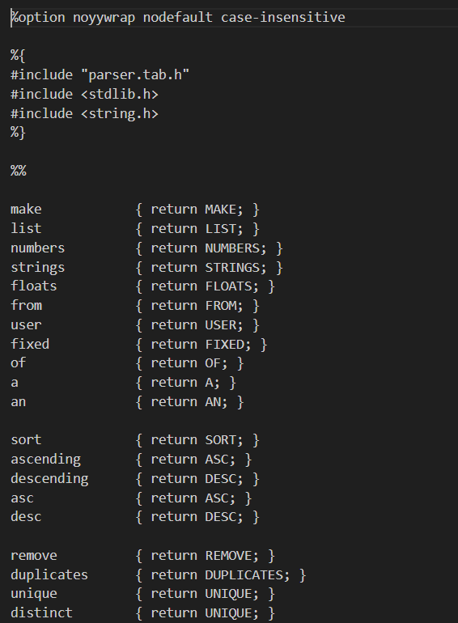
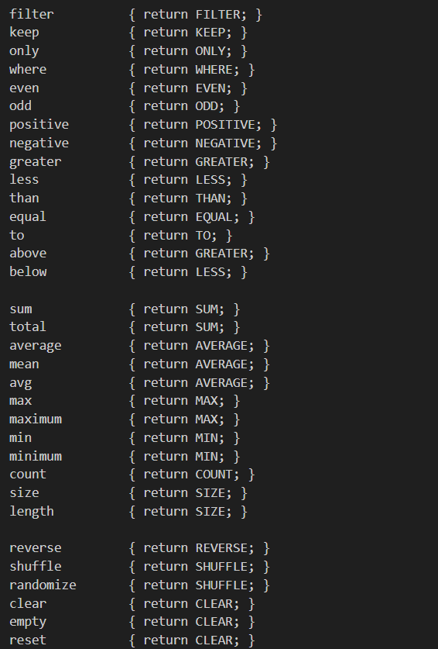
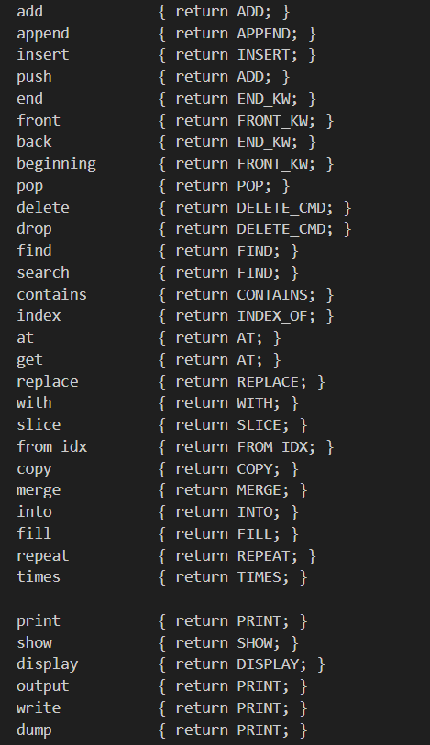
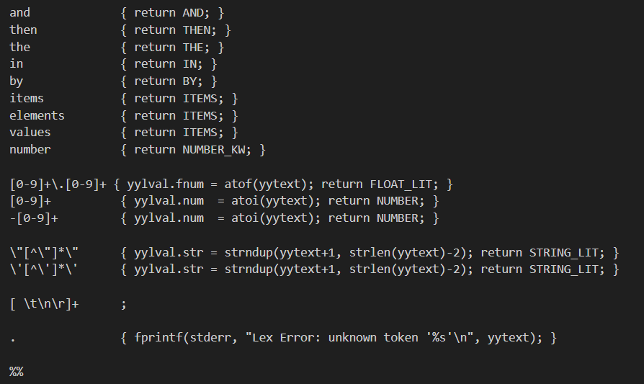

4. Parser(Grammer)
The parser is defined in parser.y. It contains the grammar of the language, written as Bison rules. The grammar organizes commands into categories. Each category handles a specific kind of operation.
Make Commands are how a list is created. The user can create a list by typing values directly with MAKE LIST FIXED, by asking for input at runtime with MAKE LIST FROM USER, or by using a built-in default list with MAKE LIST NUMBERS. Lists of integers, floats, and strings are all supported. There are also commands to fill a list with a repeated value, copy a list, or merge two lists together.
Sort Commands sort the list. The user can sort ascending, descending, or just write SORT for a default ascending sort.
Deduplication Commands remove repeated values. REMOVE DUPLICATES and KEEP UNIQUE both achieve this. Internally, the compiler sorts the list first and then uses the standard erase-unique pattern in C++.
Filter Commands keep only the elements that match a condition. The user can filter by even or odd numbers, positive or negative values, or by a numeric threshold like FILTER GREATER THAN 5. String filtering is also supported with FILTER EQUAL TO "apple". A slicing command lets the user extract a portion of the list by index range.
Statistics Commands compute and print information about the list. These include sum, average, maximum, minimum, count, and size. The user can also search for a specific value with FIND, check membership with CONTAINS, get the position of a value with INDEX OF, or access a specific position with AT.
Manipulation Commands modify the list in place. The user can reverse it, shuffle it randomly, clear it entirely, add or append values to the front or back, insert at a specific index, remove by index or by value, and replace one value with another.
Print Commands display the list. A plain PRINT or SHOW or DISPLAY prints all elements. The user can also print only even elements, only odd, only positive, or only negative. Writing PRINT ITEMS or DISPLAY ITEMS prints each element along with its index number. The user can also print statistics like sum, average, max, and min directly through display commands.
Chaining is a feature that lets the user connect multiple commands in one input using the words AND, THEN, or AND THEN. This makes a sequence of commands read like a sentence in English.

Code:
%{
#include <stdio.h>
#include <stdlib.h>
#include <string.h>

void yyerror(const char *s);
int yylex();

int list_created = 0;
int list_type = 0;

FILE *out;

const char *ctype() {
if (list_type == 1) return "double";
if (list_type == 2) return "string";
return "int";
}

#define NEED_LIST \
if (!list_created) { fprintf(out, "// Error: no list created yet\n"); } \
else
%}

%union {
int num;
double fnum;
char *str;
}

%token MAKE LIST NUMBERS STRINGS FLOATS FROM USER FIXED OF A AN
%token SORT ASC DESC BY
%token REMOVE DUPLICATES UNIQUE
%token FILTER KEEP ONLY WHERE EVEN ODD POSITIVE NEGATIVE GREATER LESS THAN EQUAL TO
%token SUM AVERAGE MAX MIN COUNT SIZE
%token REVERSE SHUFFLE CLEAR ADD APPEND INSERT POP DELETE_CMD FIND CONTAINS INDEX_OF
%token AT REPLACE WITH SLICE FROM_IDX COPY MERGE INTO FILL REPEAT TIMES
%token END_KW FRONT_KW
%token PRINT SHOW DISPLAY
%token AND THEN THE IN ITEMS NUMBER_KW

%token <num> NUMBER
%token <fnum> FLOAT_LIT
%token <str> STRING_LIT
%%

program
: command_list
;

command_list
:
| command_list command
| command_list AND command
| command_list THEN command
| command_list AND THEN command
;

command
: make_cmd
| sort_cmd
| dedup_cmd
| filter_cmd
| stat_cmd
| manip_cmd
| print_cmd
;

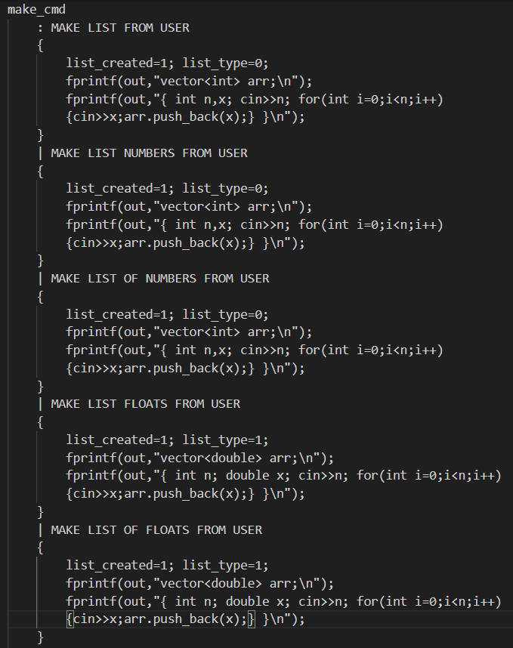
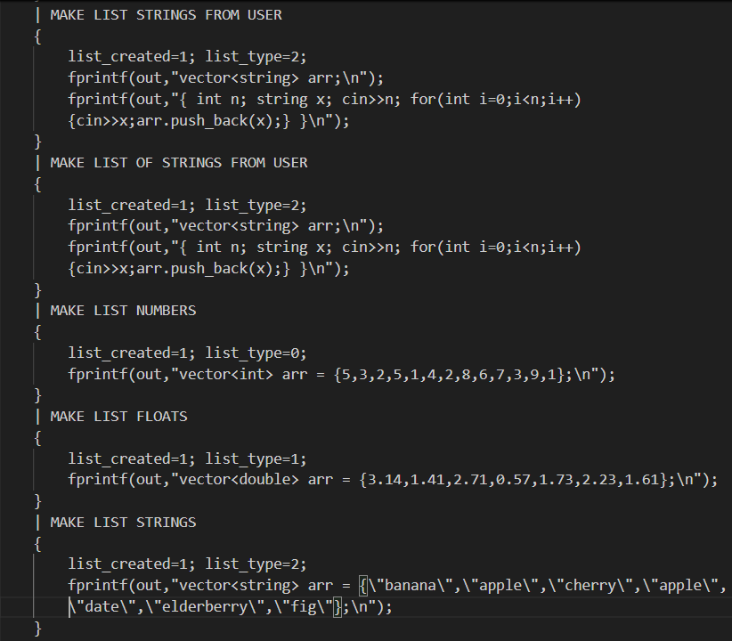
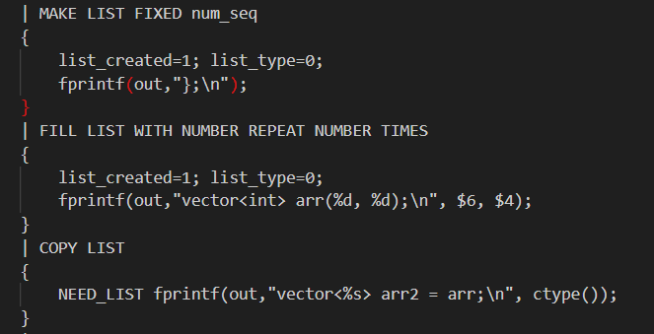
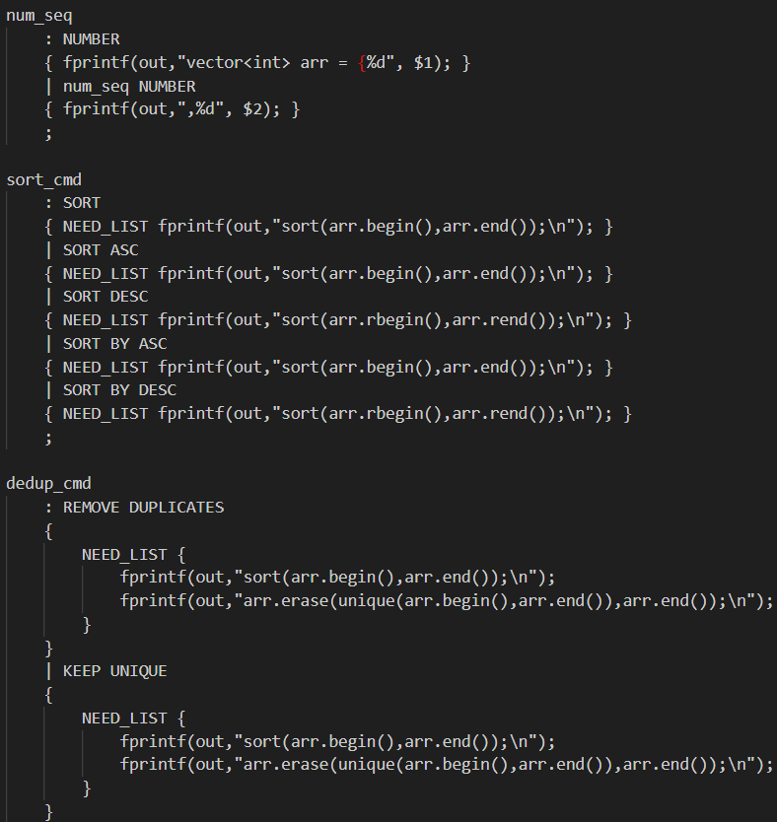
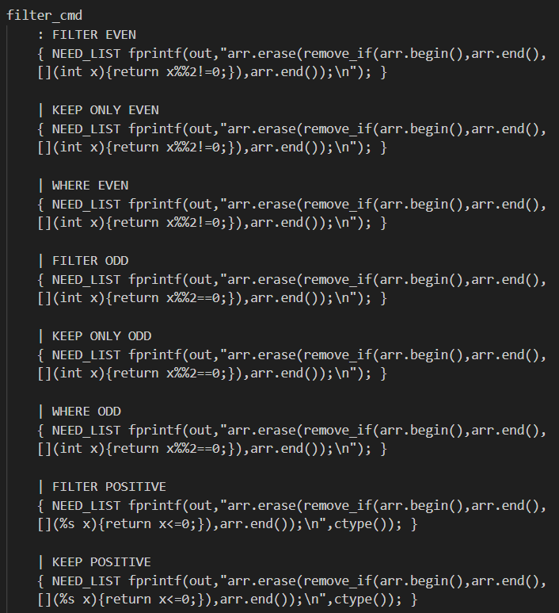
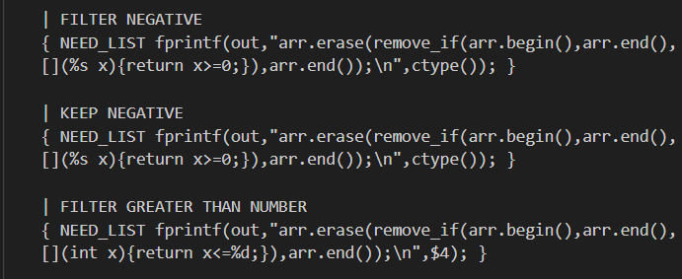
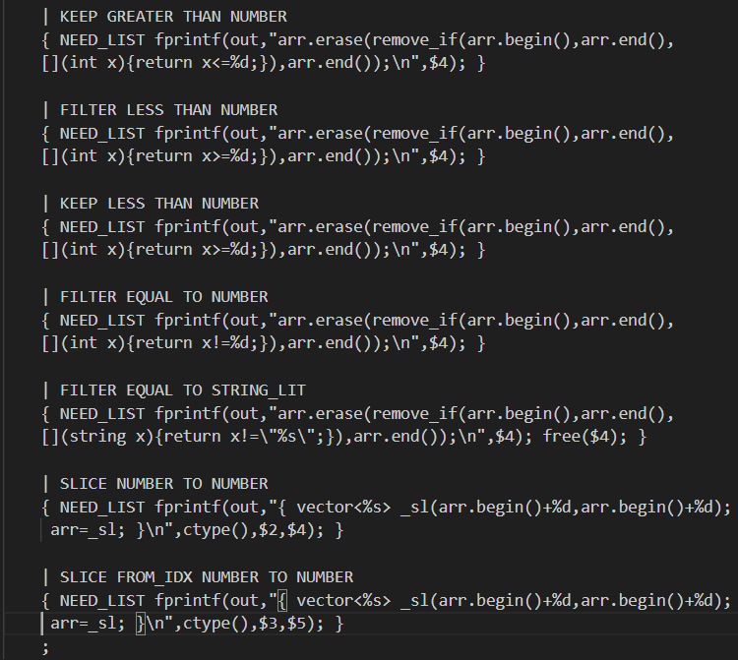
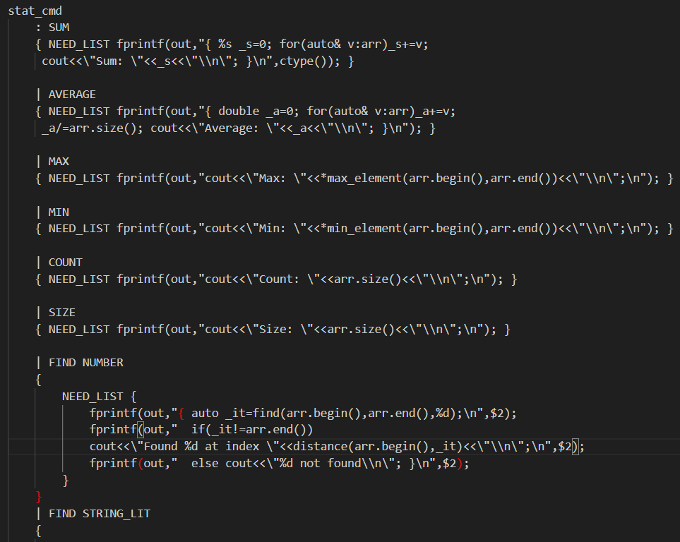
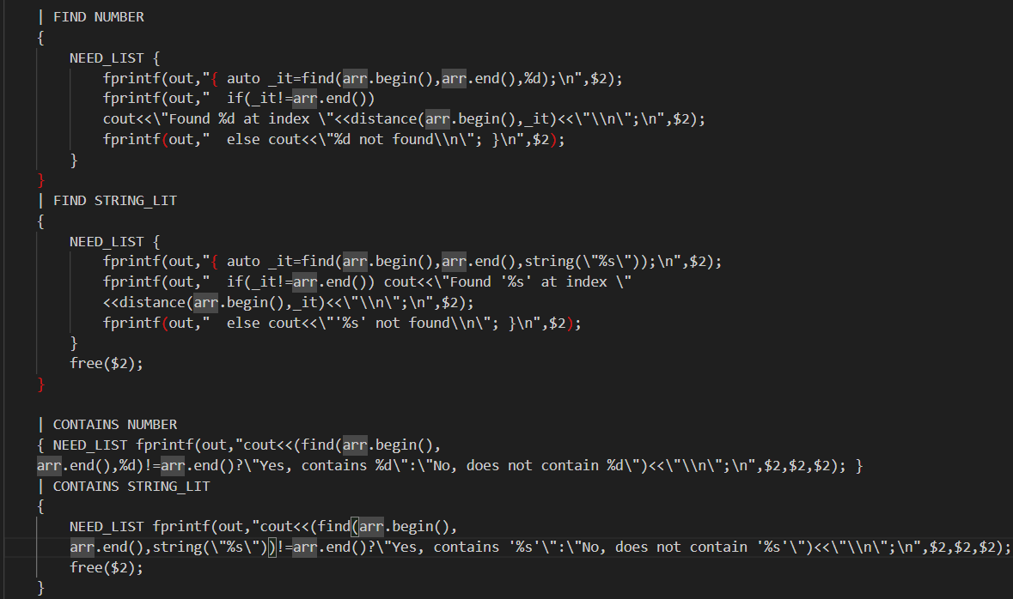
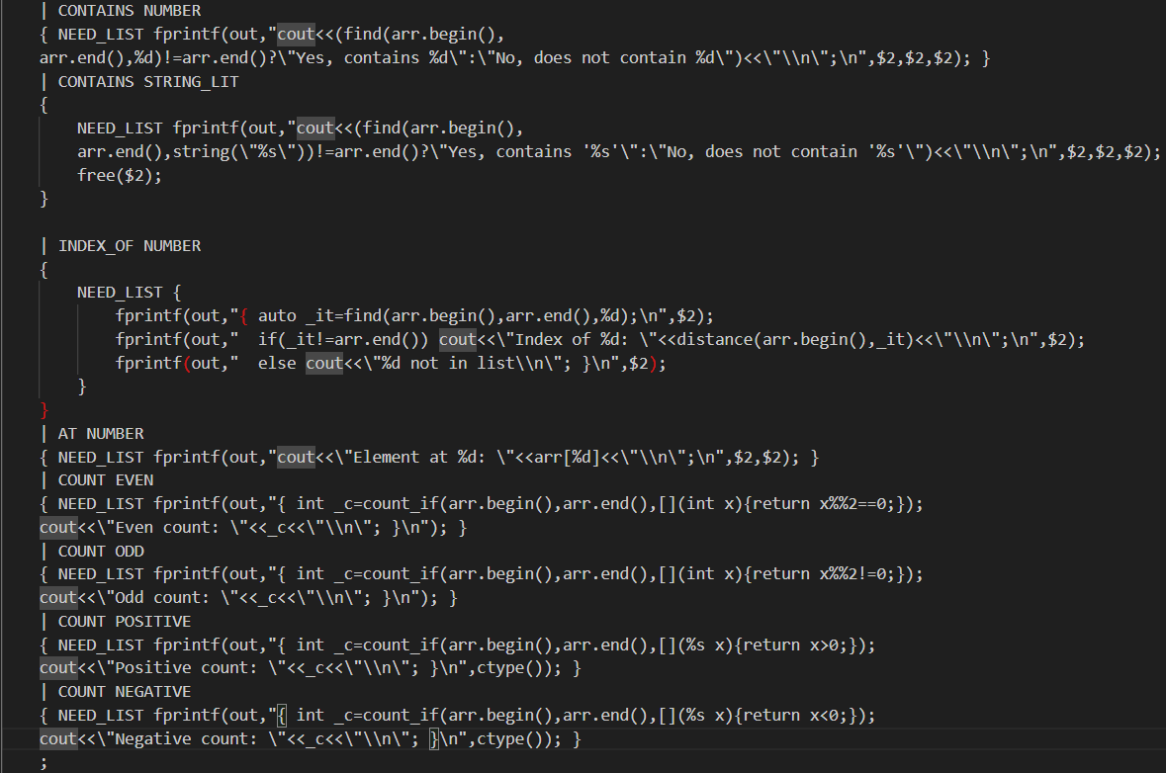
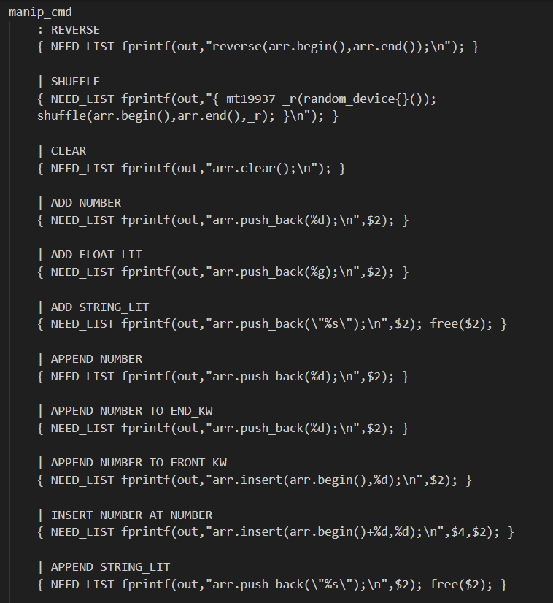
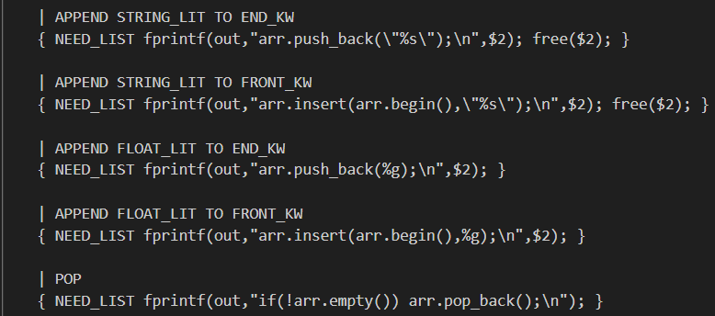
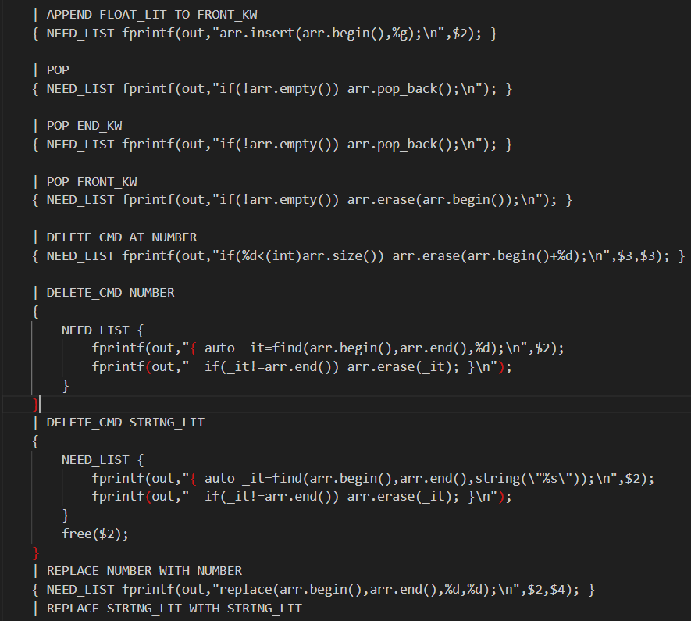
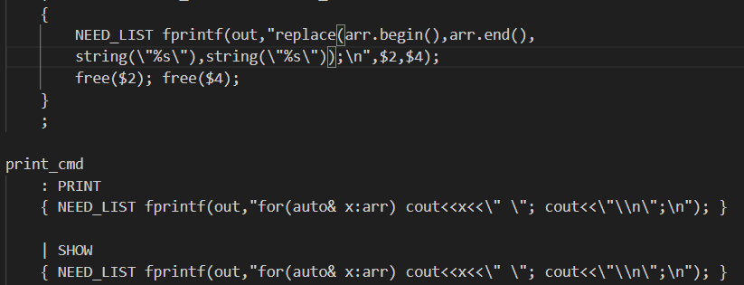
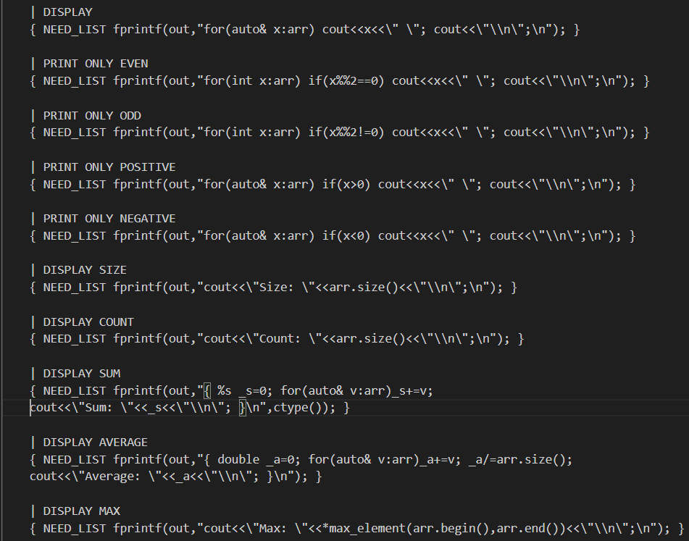
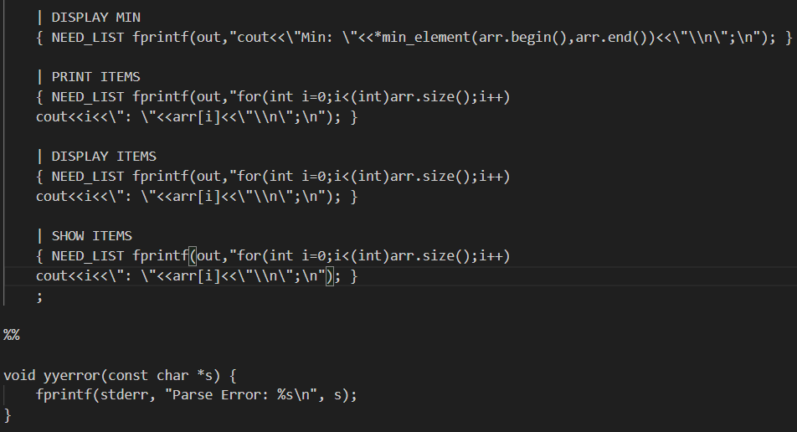
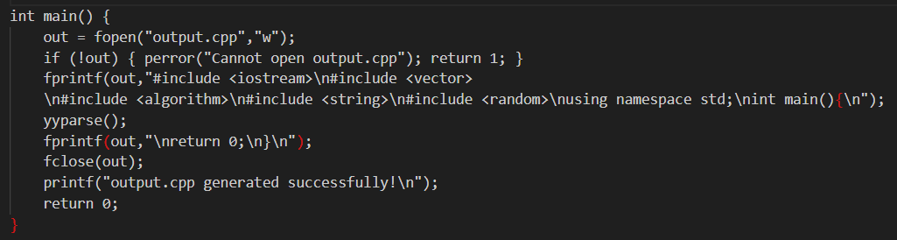

5. Code Generation
The parser does not build an abstract syntax tree. Instead, it uses direct translation, also called syntax-directed translation. The moment a grammar rule is fully matched, the corresponding C++ code is written to the output file immediately using fprintf.
The output file is a complete, standalone C++ program. The compiler writes the standard headers and the main function wrapper automatically. The user's commands are translated into the body of that main function. Once output.cpp is generated, it can be compiled with any C++ compiler like g++ and run directly.
The parser tracks two global flags internally. One flag records whether a list has been created yet. If the user tries to sort or print before creating a list, the compiler writes an error comment into the output file instead of broken code. The second flag records the type of the list, whether it is int, double, or string. This allows the generated code to use the correct C++ type in its templates and lambdas automatically.

6. Sample Run
The input file used for testing and it contains:
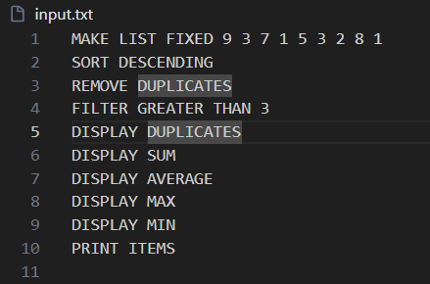
MAKE LIST FIXED 9 3 7 1 5 3 2 8 1
SORT DESCENDING
REMOVE DUPLICATES
FILTER GREATER THAN 3
DISPLAY SUM
DISPLAY AVERAGE
DISPLAY MAX
DISPLAY MIN
PRINT ITEMS
The list starts as {9, 3, 7, 1, 5, 3, 2, 8, 1}.
After sorting descending it becomes {9, 8, 7, 5, 3, 3, 2, 1, 1}.
After removing duplicates it becomes {9, 8, 7, 5, 3, 2, 1}.
After filtering to keep only values greater than 3, the list becomes {9, 8, 7, 5}.
The statistics commands then output Sum: 29, Average: 7.25, Max: 9, Min: 5.
The PRINT ITEMS command prints each element with its index, showing 0: 5, 1: 7, 2: 8, 3: 9.
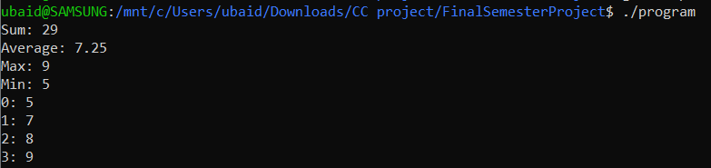

7. Novelty and Design Highlights
The main novelty of this project is its natural English syntax. Most compilers use symbolic syntax. This language uses words a non programmer can read and understand. Synonyms in the lexer, like total for sum and randomize for shuffle gives flexibility. Command chaining with AND and THEN makes multi-step programs read like instructions in plain English.
Supporting three data types, namely integers, floats, and strings, with a single unified grammar is another meaningful feature. The ctype() function in the parser dynamically selects the correct C++ type at code-generation time based on what kind of list was created. The language is also forgiving in terms of optional keywords. For example, MAKE LIST OF NUMBERS FROM USER and MAKE LIST NUMBERS FROM USER mean the same thing. The grammar handles these variations, so user is not forced to remember an exact rigid syntax.

8. Conclusion
This project successfully demonstrates the core concepts of compiler construction. The lexer tokenizes English-like input with synonym support. The parser validates command sequences against a well-defined grammar. Code generation produces complete, working C++ programs through direct syntax-directed translation. The result is a compiler that lowers the barrier to list manipulation by using natural language as the programming interface.

9. References
1. Flex and Bison by John R. Levine

